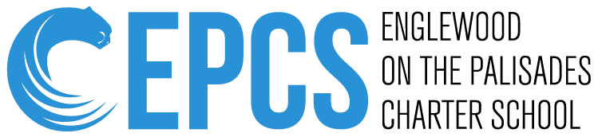

| **Dana Clark, Principal****David Block, Business Administrator** |
| --- |
| **65 West Demarest Ave Phone: (201) 569-9765**  **Englewood, New Jersey 07631 Fax: (201) 568-9576** |

Dear Middle School Parents,

On behalf of the Englewood on the Palisades Charter School, we welcome you and your children to the 2024-2025 school year! We hope you have enjoyed a wonderful summer and that you are relaxed, recharged, and ready to start a new school year.

The middle school teachers have been working diligently over the summer break to ensure a well rounded and safe school environment for the students. We assure you that this school year will be one of the most productive and enjoyable years for your children.

Middle school offers new and exciting clubs and activities your child can participate in, such as National Junior Honor Society, Young Debaters, and many more. We strive to make this upcoming year a well rounded experience for the middle school students here at EPCS.

The revised EPCS Student Handbook will be sent home with your student on the first day of school. Please make sure you review it carefully, paying close attention to the school’s policies.

We look forward to seeing the students on September 4th. Enjoy the rest of your summer and if you have any questions, please do not hesitate to reach out to the middle school teachers and/or administration.

Sincerely,

The Middle School Team