1st Grade
Summer Reading
Assignment
2023

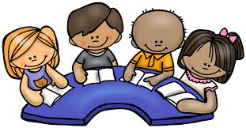

1st Grade Summer Reading Assignment

ASSIGNMENT:
- Read a total of 10 books over the summer.
- Complete the attached Reading Log to document 10 books that you’ve read.
- Choose 2 books to read and write a book report about.
  - 1 book must be fiction
  - 1 book must be nonfiction

There are two copies of each kind of book report attached so you can be sure to have what you need depending on the books you choose to read.

This assignment is due on the first day of school in September and will count as your first writing grade. There is a grading rubric attached so you can see the expectations for this assignment.

Please use the free resources below if you’re unable to go to the library or purchase books.

The Bergen County Cooperative Library Service offers ebooks you can borrow and read. Just go to www.bccls.org to sign up for an online library card.

Scholastic Storia

https://www.wilbooks.com/free-resources

https://www.readacrossamerica.org/

http://www.storylineonline.net/

https://storytimefromspace.com/

If you have any questions, please feel free to reach out via email:

Mrs. Ferrentino - laura.ferrentino@epcs.ws

See you in September!

Reading List
Easy Readers
If your 1st grader is looking for silly books, read:
- My Toothbrush is Missing by Jan Thomas
- What is Chasing Duck? by Jan Thomas
- We Are in a Book by Mo Willems (all Elephant and Piggie books are fantastic!)
- The Big Fat Cow That Goes Kapow by Andy Griffiths

If your 1st grade child likes stories about real life and friendship, try:
- Who Is That, Cat the Cat? by Mo Willems
- We Are Growing by Laurie Keller
- Don’t Worry, BEE Happy by Ross Burach
- Big Cat by Ethan Long
- The Cookie Fiasco by Dan Santat
- Baby Monkey, Private Eye by Brian Selznick & David Serlin
- Lazy Bear, Crazy Bear by Kevin Bolger
- Trucktown by Jon Scieszka

If your 1st grader likes animal stories, try reading:
- Slow, Slow Sloths by Bonnie Bader
- Little Big Horse by Dave Horowitz
- We Dig Worms by Kevin McCloskey

Easiest Chapter Books - Easy chapter books have pictures with words. The easiest chapter books have just a few sentences per page. Try these first grade favorites..
- Fly Guy by Tedd Arnold – FUNNY
- See the Cat: Three Stories About a Dog by David LaRochelle – FUNNY
- Hi, Jack! (A Jack Book) by Mac Barnett & Greg Pizzoli – FRIENDSHIP
- Do You Like My Bike? (Hello, Hedgehog!) by Norm Feuti – FRIENDSHIP
- An Elephant & Piggie Biggie! by Mo Willems – FUNNY
- Aggie the Brave by Lori Ries – FRIENDSHIP
- Caterpillar to Butterfly by Laura Marsh – NONFICTION
- Mr. Putter and Tabby Walk the Dog by Cynthia Rylant – FRIENDSHIP
- Frog and Toad Are Friends by Arnold Lobel – FRIENDSHIP
- Penny and Her Marble by Kevin Henkes – REALISTIC
- Narwhal: Unicorn of the Sea by Ben Clanton – FRIENDSHIP

Easy Chapter Books - Easy chapter books have bigger text with pictures every few pages. These books listed range from middle of 1st grade to beginning of second-grade reading levels.
If your first grader likes animal main characters, read:
- Kitty and Dragon by Meika Hashimoto
- Pug Blasts Off (Diary of a Pug) by Kyla May
- Kung Pow Chicken by Cindi Marko
- Owly: The Way Home and The Bittersweet Summer by Andy Runton

If your 1st grade children like funny books, try:
- Smell My Foot (Chick and Brain) by Cece Bell
- Moldylocks and the Three Beards by Noah Z. Jones
- Meet Mo and Jo: The Boulder Brothers by Sarah Lynn
- The Infamous Ratsos by Kara Lareau
- Geeger the Robot Goes to School by Jarret Lerner

If your 1st grade kids like realistic books, read:
- Meet Yasmin! by Saadia Faruqui
- Happy Paws: Layla and the Bots by Vicky Fang
- The Party and Other Stories (Fox and Chick) by Sergio Ruzzier
- Kitty and the Moonlight Rescue by Paula Harrison
- Mia Mayhem Is a Superhero! by Kara West

If your 1st graders like adventure & fantasy books, try:
- Bo’s Magical New Friend (Unicorn Diaries) by Rebecca Elliott
- The Princess in Black by Shannon Hale and Dean Hale
- Ricky Ricotta’s Mighty Robot #1 by Dav Pilkey
- Notebook of Doom #1 by Troy Cummings
- Rise of the Earth Dragon #1 by Tracey West

More Challenging Chapter Books

If your reader loves graphic novels, try these choices:
- Cat Kid Comic Club by Dav Pilkey
- Bird and Squirrel on Ice by James Burks
- Mr. Wolf’s Class: Mystery Club by Aron Nels Steinke
- Cat Ninja by Matthew Cody
- King of the Birds by Elise Gravel
- Guinea Pig, Pet Shop Private Eye by Colleen AF Venable

If your reader likes funny books, they’ll love:
- Planet Omar by Zanib Mian
- The Dragonsitter by Josh Lacey
- Stick Dog by Tom Watson
- The Case of the Weird Blue Chicken by Doreen Cronin
- Real Pigeons Fight Crime by Ben Wood
- Rabbit & Bear: Rabbit’s Bad Habits by Julian Gough & Jim Field

If your child likes magic and mythical creatures, they’ll love:
- Dragons and Marshmallows: Zoey and Sassafras by Asia Citro
- Diary of an Ice Princess: Snow Place Like Home by Christina Soontornvat
- Rise of the Earth Dragon by Tracey West
- Magical Animal Adoption Agency by Kallie George
- The Fabled Stables Willa the Wisp by Jonathan Auxier

If your child likes adventure stories, they’ll love:
- Zita the Spacegirl by Ben Hatke
- Magic Tree House by Mary Pope Osborne
- Galaxy Zack by Ray O’Ryan
- The Notebook of Doom by Troy Cummings
- Ricky Ricotta’s Mighty Robot by Dav Pilkey
- Rescue on the Oregon Trail by Kate Messner

If your reader likes mysteries, they’ll love:
- The Haunted Library by Dori Hillestad Butler
- The Whodunit Detective Agency by Martin Widmark
- A to Z Mysteries by Ron Roy
- Secret Spy Society The Case of the Missing Cheetah by Veronica Mang
- Mac Undercover (Kid Spy #1) by Mac Barnett
- Crime Biters: My Dog Is Better Than Your Dog by Tommy Greenwald

If your child loves realistic stories, try:
- Amelia Bedelia Means Business by Herman Parish
- Too Small Tola by Atinuke
- Dory Fantasmagory by Abby Hanlon
- Stink by Megan McDonald
- Bark Park by Brandi Dougherty
- The Amazing Life of Azaleah Lane by Nikki Shannon Smith

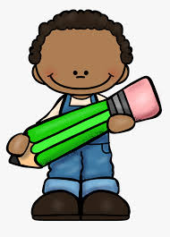
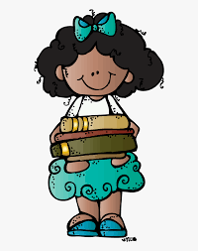
Name: Date:

Fiction Book Report

Title:
Author:

What happened in the beginning of the story?

What happened in the middle of the story?

What happened at the end of the story?

Did you like the story? Why or why not?

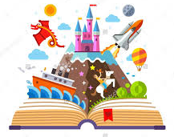
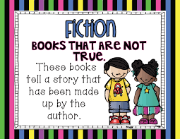

Name: Date:

Fiction Book Report

Title:
Author:

What happened in the beginning of the story?

What happened in the middle of the story?

What happened at the end of the story?

Did you like the story? Why or why not?

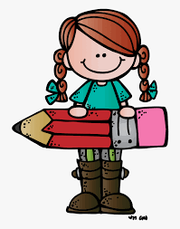
Name: Date:

Nonfiction Book Report
Title:
Author:

Fact 1:

Fact 2:

Fact 3:

Vocabulary word:

Definition:
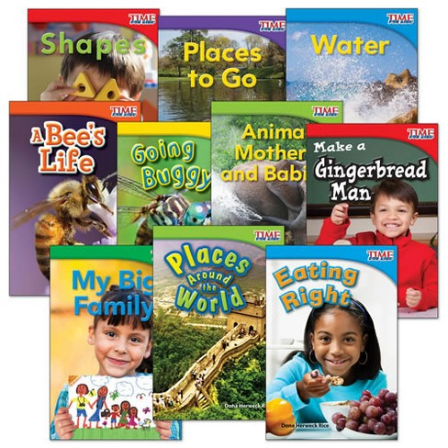
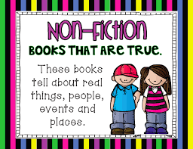

Name: Date:

Nonfiction Book Report
Title:
Author:

Fact 1:

Fact 2:

Fact 3:

Vocabulary word:

Definition:

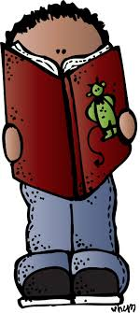
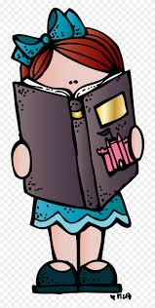
Name:
Reading Log Summer 2022

Complete the Reading Log to show 10 books that you read this summer.

Book Title | Author | Parent  Initials

Grading Rubric (All Reports)

Category | 3 | 2 | 1 | Points
Content -  Fiction Book Report(s) | Writing clearly and correctly tells what happens in the beginning, middle, and end of the story | Writing tells what happens in the beginning, middle, and end of the story, but some parts may not be clear | Writing is unclear and/or some parts are not filled in.
Content - Nonfiction Book Report(s) | Facts clearly and correctly relate to the subject of the book  Vocabulary definition is accurate | Facts somewhat relate to the subject of the book  Vocabulary sentence is somewhat accurate | Facts do not relate to the subject of the book  Vocabulary sentence does not make sense
Conventions | Writing shows excellent control of writing conventions (spelling, capitalization, punctuation) | Writing shows fair to good control of writing conventions (spelling, capitalization, punctuation) | Writing shows poor control of writing conventions (spelling, capitalization, punctuation)
Appearance | Handwriting is very neat and legible | Handwriting is somewhat neat and legible | Handwriting is not neat and is difficult to read

Scale: 12 - 100% 9 - 75% 6 - 50%
11 - 92% 8 - 67% 5 - 42%
10 - 83% 7 - 58% 4 - 33%

